
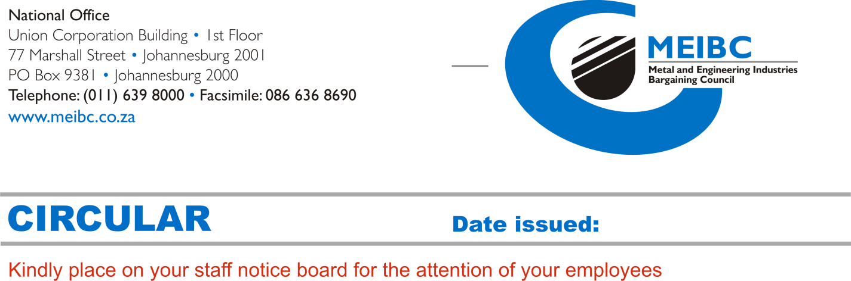
1 June 2011
To: General Manager

INCREASE IN THE MEIBC ADMINISTRATION AND DISPUTE RESOLUTION LEVIES

The Management Committee of the Metal and Engineering Industries Bargaining Council (MEIBC) has approved an increase in the council’s administration and dispute resolution levies with effect from 1 July 2011. The levy increases have become necessary in order to ensure that the council is financially sustainable to continue fulfilling its role in terms of the Labour Relations Act.

Current Administration Levy |  |  | NEW ADMINISTRATION LEVY  with effect from 1 July 2011
Per week | Per Month | Monthly Minimum | Per week | Per Month | Monthly Minimum
R1.62 | R7.02 | R162.00 | R1.72 | R7.45 | R175.00
- The Administration Levy is payable by each scheduled employee, with a matching contribution paid by the employer per scheduled employee.
- The employer must make up any shortfall where contributions to the administration levy are less than R175.00 per month.

Current Dispute Resolution Levy |  | NEW DISPUTE RESOLUTION LEVY  with effect from 1 July 2011
Per Week | Per Month | Per Week | Per Month
57 cents | R2.47 | 62 cents | R2.68
- The Dispute Resolution Levy is payable by all employees (including non-scheduled employees), with a matching contribution paid by the employer per employee.

The new levies will be reflected in the July return, which will be dispatched mid July 2011. Kindly take note that deductions of the new levies in respect of weekly paid employees must be effected from the first week in July 2011.

Should you require any further information, please contact the MEIBC regional office in your area listed on the left.

Thank you for your cooperation.
Yours sincerely
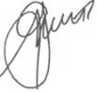
Alistair Smith
Chief Executive Officer

